Wraparound Childcare Finder Guide
The Wraparound Childcare Finder for the school is in the secure area of Bradford Schools Online (BSO) this can be accesses in the maintenance tools when you login to BSO. Click on the ‘Wraparound Childcare’ button
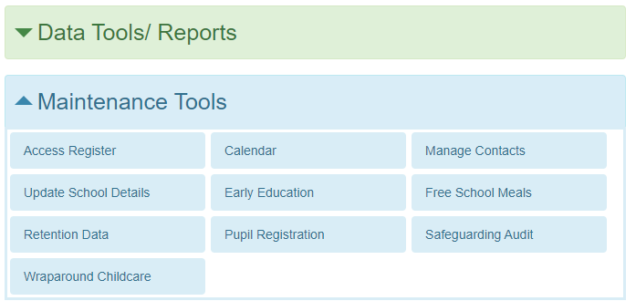
This will open up your schools page and is set up with the schools’ details at the top and the Wraparound Childcare Providers (or linked providers) who offer Wraparound Childcare to children. We have hidden contact details in the below for privacy, but this will show you all the options when you log in. below. You can export this page to a PDF document to share with your families
If no providers are showing this means your school may not have any linked providers.

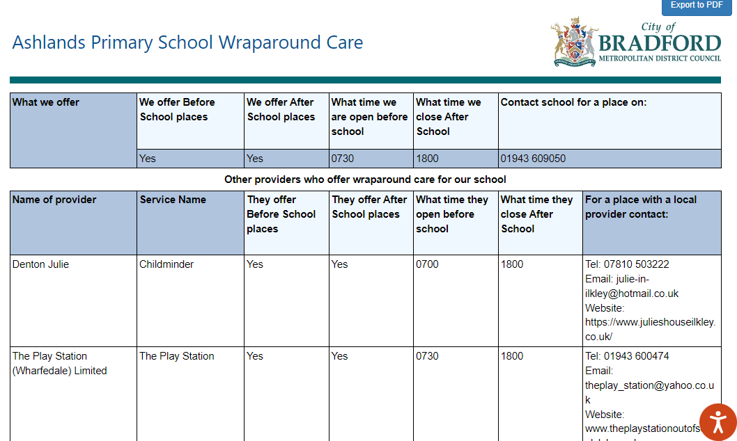
N.B This contains only providers who given permission to share their details, there might be other childcare providers who offer this service to families too. If you have providers that you would want to be included ask them to contact sufficiency@bradford.gov.uk

