  Food Hygiene Rating Scheme: Consent for early publication of rating | 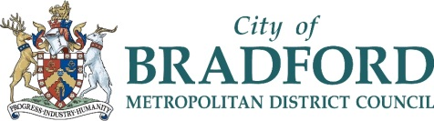 | 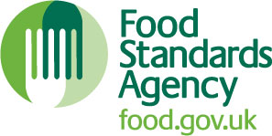

Notes for businesses
- As the food business operator of the establishment you may request that your new rating is published on www.food.gov.uk/ratings before the period in which you can appeal against the rating has elapsed
- Please use the form below and return it to: Food Safety Team, Bradford Metropolitan District Council, Britannia House, Broadway, Bradford, BD1 1HX or email to: eh.admin@bradford.gov.uk
- The Food Safety Team will review your request and will usually publish the rating early. If there are any issues or queries, such as the Food Safety needing to confirm your position within the business, they will contact you.

Business details
Food business operator/proprietor

Business name

Business addresses

Business tel. number |  | Business email

Inspection details
Date of inspection |  | Food hygiene rating given

Consent to publish rating before the end of the appeal period
I request the publication of the rating from the above inspection on www.food.gov.uk/ratings before the period in which the rating may be appealed has elapsed.
Signature
Name in capitals
Position Date
Contact tel. number
Contact email

